**C.M.D.A.V. Sen. Sec. Public School, Mandi Dabwali**

**Class –L.K.G.**

**Summer vacation homework**

Dear Students,

1. Do your work by yourself.
2. Do your work neat and clean.
3. Do all written work in your mix notebook.

**Written work**

**. (English)**

**Capital letters – A to H ( 5 times)**

**. (Hindi )**

**अ से अ: तक (5 Times)**

**. (Maths)**

**Counting 1 to 10(5 times)**

**(Book Reading )**

1. **Fun with English – Read Pg. no. 12 to 29**
2. **अक्षर परिचय–Read Pg. no. 1 to 10**

**(Revise G.K. )**

**.What is your name?**

**. What is the colour of apple, banana,grapes?**

**(Revise Rhymes)**

**English -Bits of paper ,Hop a little**

**Hindi -कबूतर ,‌ तोता**

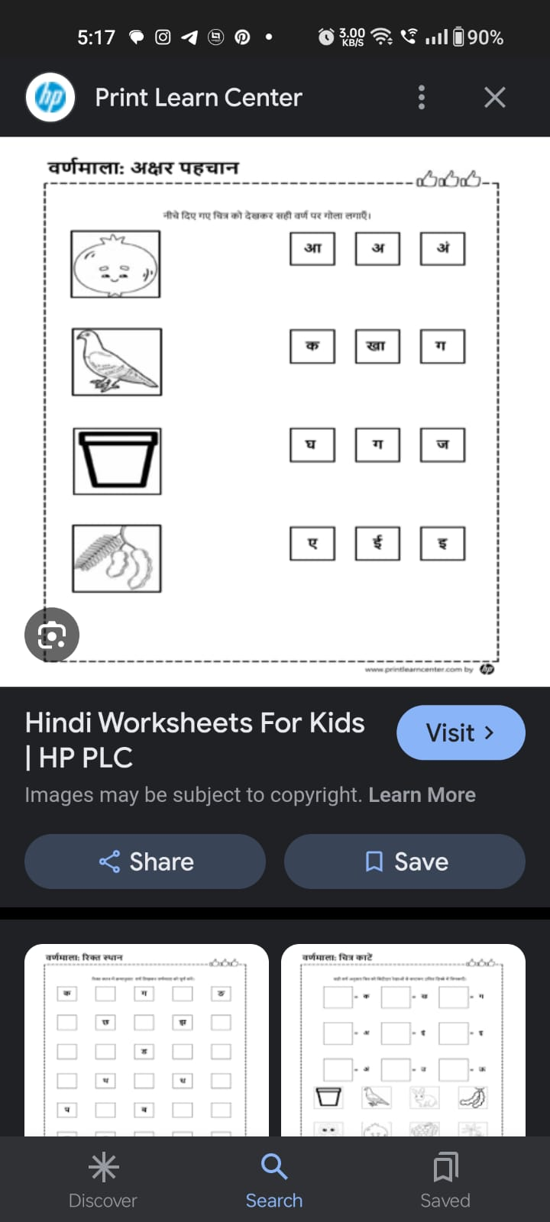

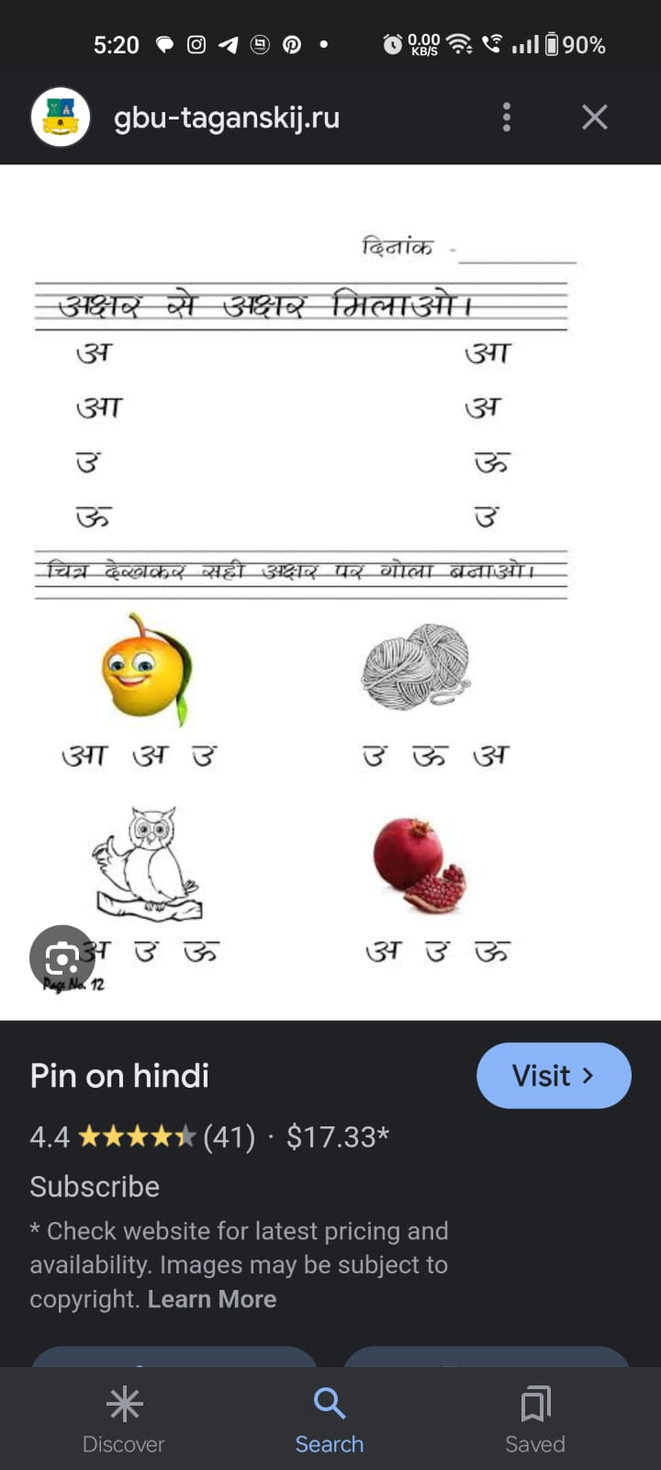

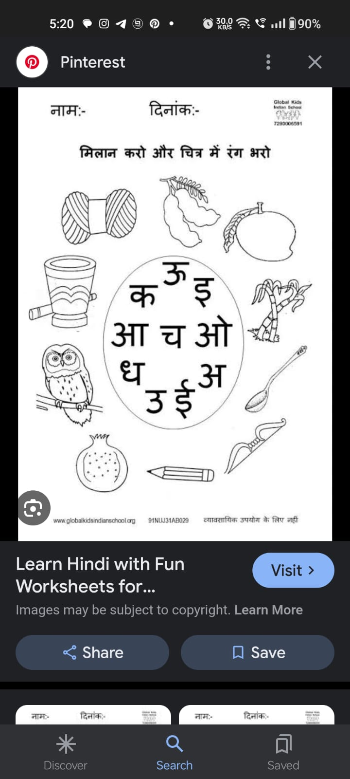

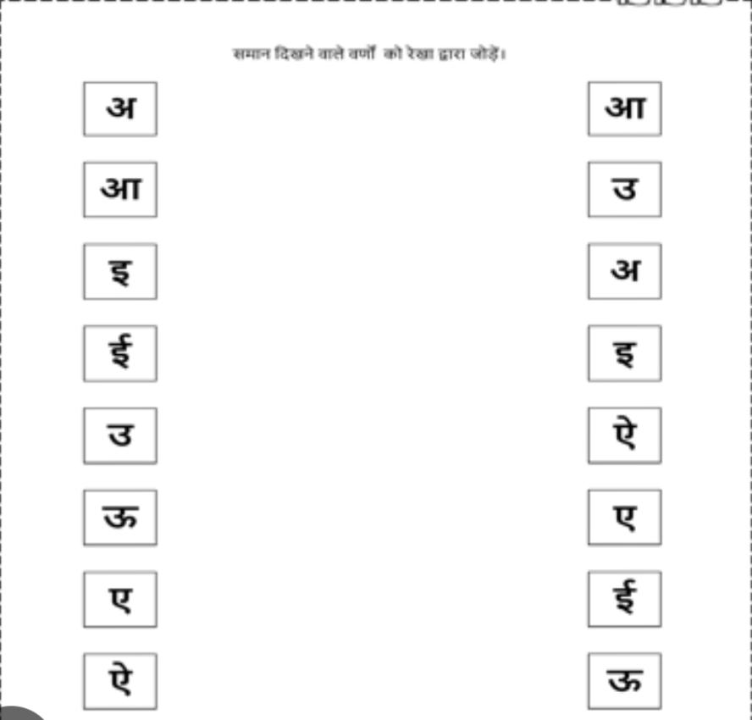सामान दिखने वाले स्वरों को को मिलाये

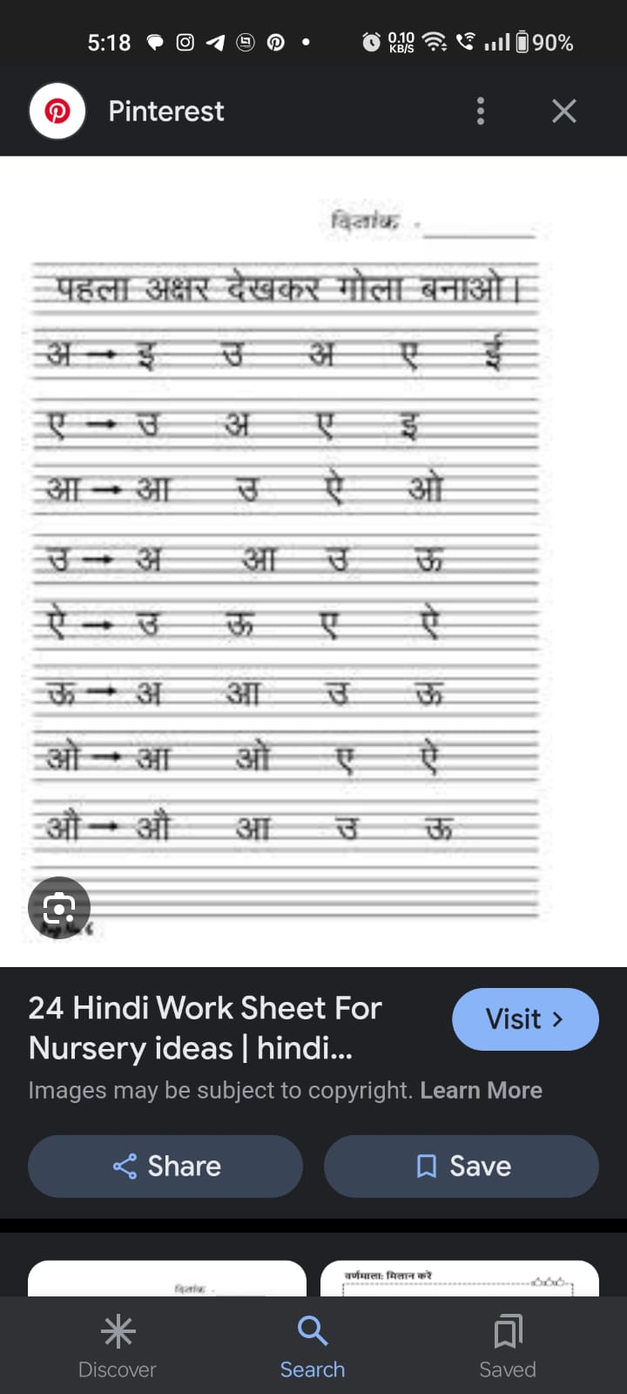

Maths

.Count and write

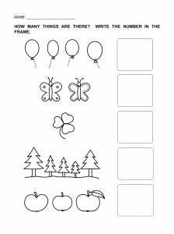

.Matching with same numbers

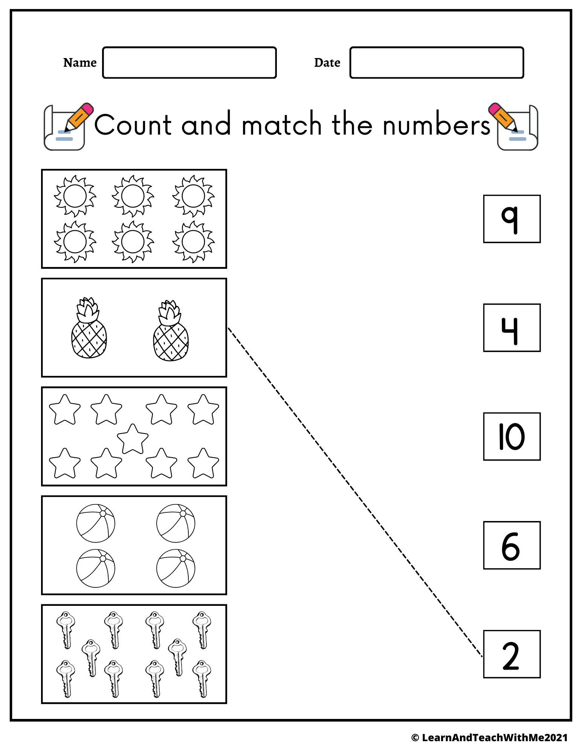

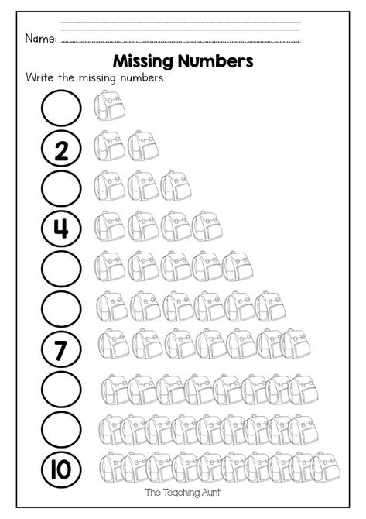

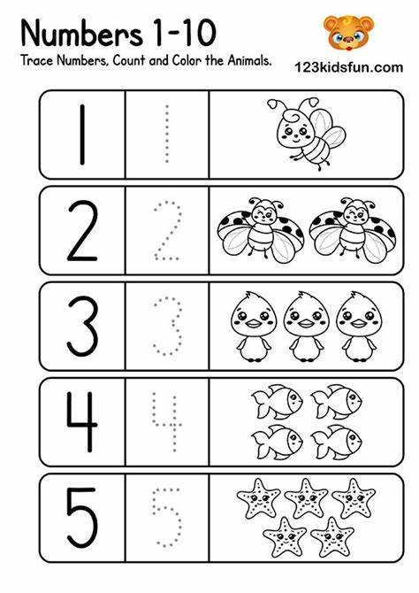

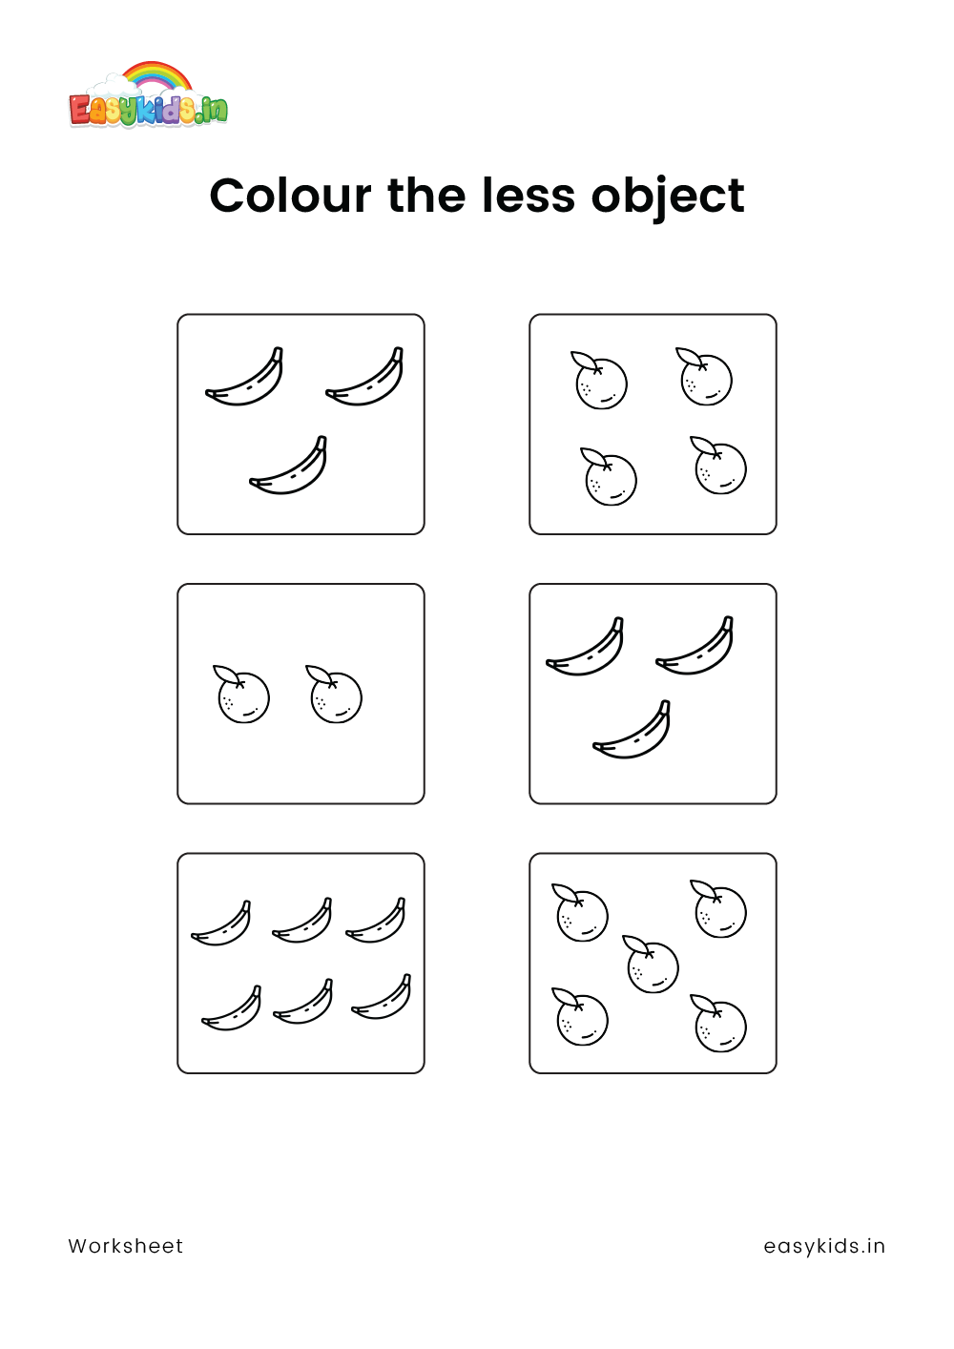

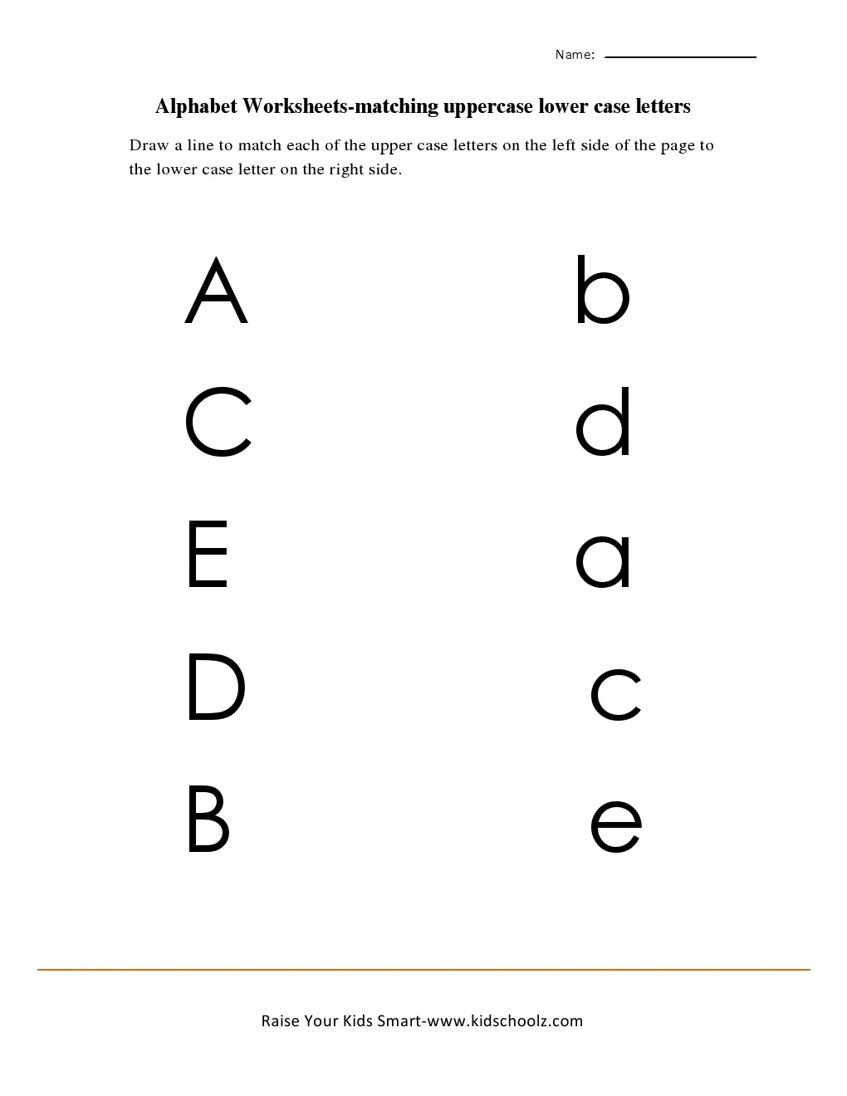

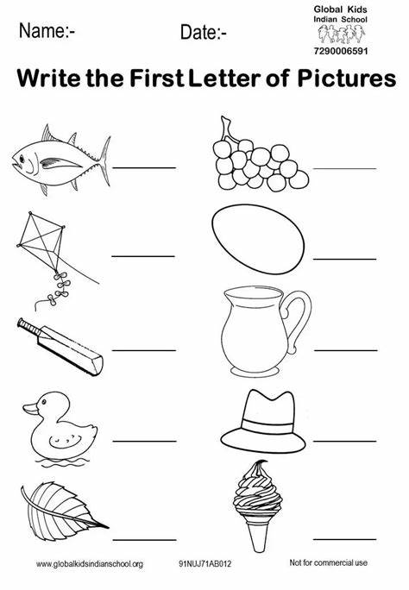

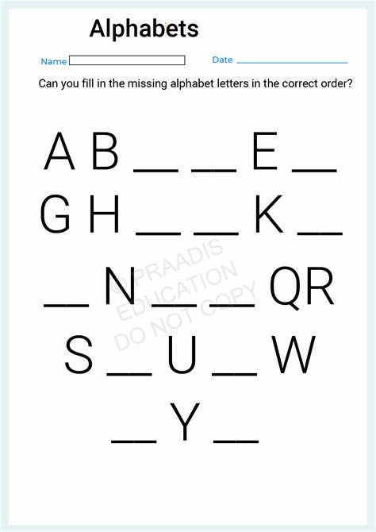

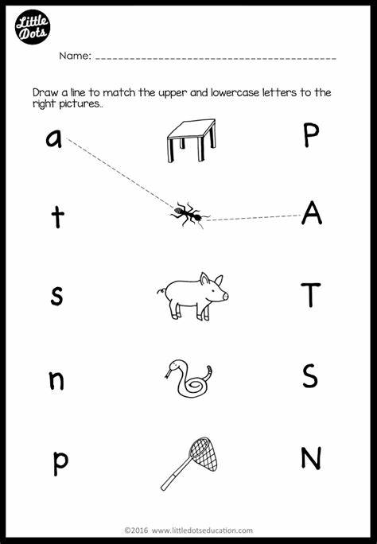

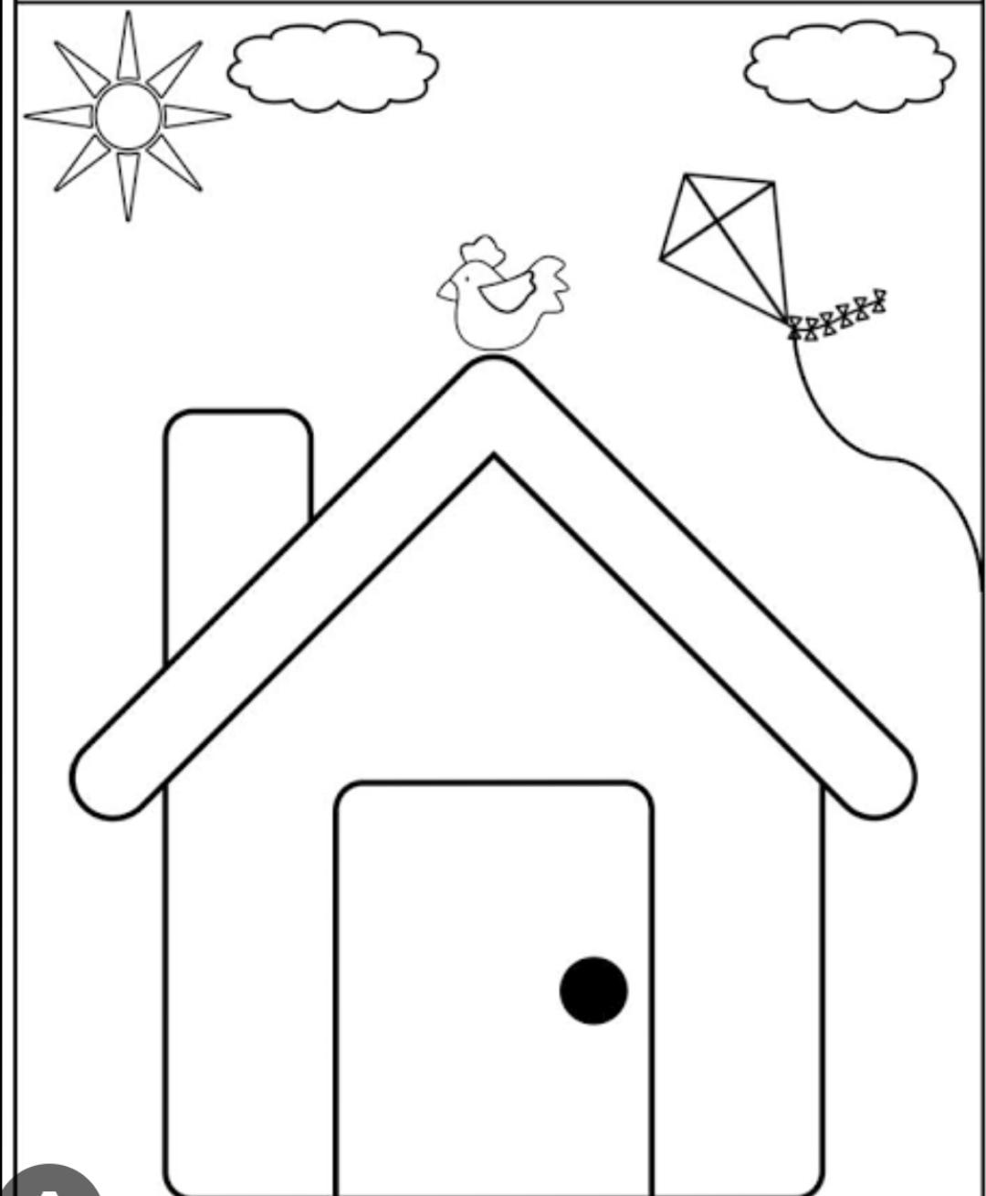. Colour the picture

